E-Commerce Sales Analysis – Project Documentation
Introduction
The e-commerce industry generates large volumes of transactional data every day. Analyzing this data enables organizations to understand customer purchasing behavior, monitor business performance, identify profitable products, and make informed strategic decisions.
This project analyzes an e-commerce sales dataset containing 15,000 transaction records. The project follows the complete data analytics lifecycle, including data cleaning, exploratory data analysis, SQL-based business analysis, and interactive dashboard creation using Power BI. The objective is to transform raw sales data into meaningful business insights that support decision-making.
Business Objective
The objective of this project is to analyze historical e-commerce sales transactions to evaluate overall business performance. The analysis focuses on identifying revenue trends, profitability, customer purchasing patterns, product performance, regional sales distribution, and payment preferences.
The insights generated from this project will help business stakeholders make informed decisions to improve sales performance, optimize product strategies, and increase profitability.
Business Background
The organization operates an e-commerce platform that sells products across multiple product categories and locations. Daily customer transactions generate valuable business data containing information about sales, profits, product categories, customer purchases, and payment methods.
Management wants to better understand business performance by identifying trends, measuring key performance indicators, and discovering opportunities for improving revenue and profitability.
Dataset Overview
The dataset used in this project contains approximately 15,000 e-commerce sales transactions. Each row represents a single customer order and includes information related to customer purchases, product details, sales amount, discounts, profit, payment methods, and geographical location.
The dataset is structured and suitable for performing business analysis, trend identification, KPI measurement, and dashboard reporting.
Data Summary Table
Attribute | Value
Dataset Name | E-Commerce Sales Dataset
Total Records | 15,000
Total Columns | 12
Dataset Type | Structured
Data Format | Excel (.xlsx)
Analysis Tools | MySQL, Power BI

Data Description
Column | Description | Data Type
Order_ID | Unique order number | Text
Order_Date | Order ate | Date
Customer_ID | Customer identifier | Text
Product_Category | Product category | Text
Product_Name | Product name | Text
State | Customer state | Text
City | Customer city | Text
Payment_Mode | Payment method | Text
Quantity | Number of units purchased | Number
Sales_Amount | Revenue generated | Decimal
Discount | Discount provided | Decimal
Profit | Profit earned | Decimal

Business Question
Business Performance
- What is our total sales revenue?
- What is our total profit?
- Which month generated the highest sales?
- Which month generated the lowest sales?
- Is our sales trend improving or declining over time?
Product Performance
- Which product category generates the highest revenue?
- Which product category generates the highest profit?
- Which products are our top revenue generators?
- Which products generate the least revenue?
- Which products generate losses despite good sales?
Customer Behavior
- Which payment method do customer prefer the most?
- Which payment method contributes the highest revenue?
- Are Customer purchasing multiple quantities in a single order?
- Which customer place the highest-value orders?
- What is the average order value?
Geographic Analysis
- Which state generates the highest sales?
- Which state generates the highest profit?
- Which city contributes the highest revenue?
- Which cities have poor sales performance?
Discount Analysis
- Does offering higher discounts actually increase sales?
- How do discounts impact profit?
Operations
- Which days or months experience the highest order volume?
- Which products have the highest sales quantity?
Strategic Questions
- Based on the analysis, where should we invest more?
- What are your top business recommendations to improve revenue and profitability?

Key Performance Indicators (KPIs)
KPI | Definition | Business Importance
Total Sales | Total revenue generated | Measures business size
Total Profit | Total profit earned | Indicates profitability
Total Orders | Number of customer orders | Showa transaction volume
Total Quantity Sold | Total items sold | Measures sales volume
Average Discount | Average discount applied | Evaluates pricing strategy

Project Scope:
In Scope
- Data Cleaning
- Data Validation
- SQL Analysis
- KPI Calculation
- Business Insights
- Dashboard Development
- Trend Analysis
Out of Scope
- Machine Learning
- Sales Forecasting
- Customer Chrum Prediction
- Inventory Optimization
- Marketing Campaign Analysis
Assumptions
- Each row represents one completed customer order.
- Sales_Amount is assumed to represent the revenue generated by the order.
- Profit values are assumed to be correctly calculated.
- Dates are assumed to be valid after cleaning.
- Product categories and geographical fields are assumed to be standardized after data cleaning.
- The dataset is assumed to accurately represent the business transactions available for analysis.
Expected Deliverables
Deliverable | Tools
Cleaned Dataset and SQL Analysis | MySQL
Dashboard | Power BI
Project Documentation and Business Report | Microsoft Word

Project Workflow
- Business Understanding
- Project Documentation
- Data Cleaning
- Import into MySQL
- Exploratory Data Analysis
- Business Analysis
- Power BI Dashboard
- Business Insights
- Final Report
Data Dictionary:
Column | Data Type | Description | Example
Order_ID | Varchar | Unique identifier for each order | ORD100000
Order_Date | Date | Date on which order was placed | 11 – 07 – 2023
Customer_ID | Varchar | Unique customer identifier | CUST8187
Product_Category | Varchar | Category of product | Electronics
Product_Name | Varchar | Name of product | Laptop
State | Varchar | Customer’s State | Tamil Nadu
City | Varchar | Customer’s City | Chennai
Payment_Mode | Varchar | Payment method used | UPI
Quantity | INT | Number of units purchased | 2
Sales_Amount | Decimal / Double | Revenue generated | 25000
Discount | Decimal / Double | Discount Percentage / Value | 10
Profit | Decimal / Double | Profit generated | 3500

Data Source & Import:
The dataset was provided in CSV format and imported into MySQL for data preparation, cleaning and analysis.
Data Cleaning:
Data cleaning steps:
- Checked table structure using Describe
- Checked missing / blank values
- Checked duplicate records
- Standardized text fields
- Converted Order_Date into proper date format
- Checked numerical columns
- Checked invalid values
- Validated the cleaned dataset
Cleaning Activity | Result
Missing Values | Checked
Duplicate records | Checked
Blank Product Names | Checked
Date format | Standardized
Text values | Standardized
Numeric fields | Validated

EDA
Sales:
- Total Sales
- Average Sales
- Minimum Sales
- Maximum Sales
Profit:
- Total Profit
- Average Profit
- Highest Profit
- Lowest Profit
Quantity:
- Average Quantity
- Maximum Quantity
Time:
- Monthly Orders
- Monthly Sales
- Monthly Profit
Geography:
- States
- Cities
Products:
- Product Categories
- Products

Business Analysis:
Analysis | Question | Finding | Recommendations
Sales | Which state / city performs best? | Rajasthan has the highest sales | Strengthen marketing and customer – retention activities in Rajasthan
Product | Which category / product performs best? | Electronics has the highest sales. | Maintain sufficient inventory an promote high – performing electronics products
Customer | Who are the valuable / frequent customers? | A small group of customers contributes significant revenue | Introduce loyalty or retention campaigns for high – value customers
Payment | Which payment method is preferred? | Cash on delivery is widely used | Maintain a smooth COD experience while encouraging convenient
Discount | Are discounts affecting profit? | Higher discounts coincide with lower profit | Review discount levels and set discount limits based on profitability

Power BI & DAX
Data Model
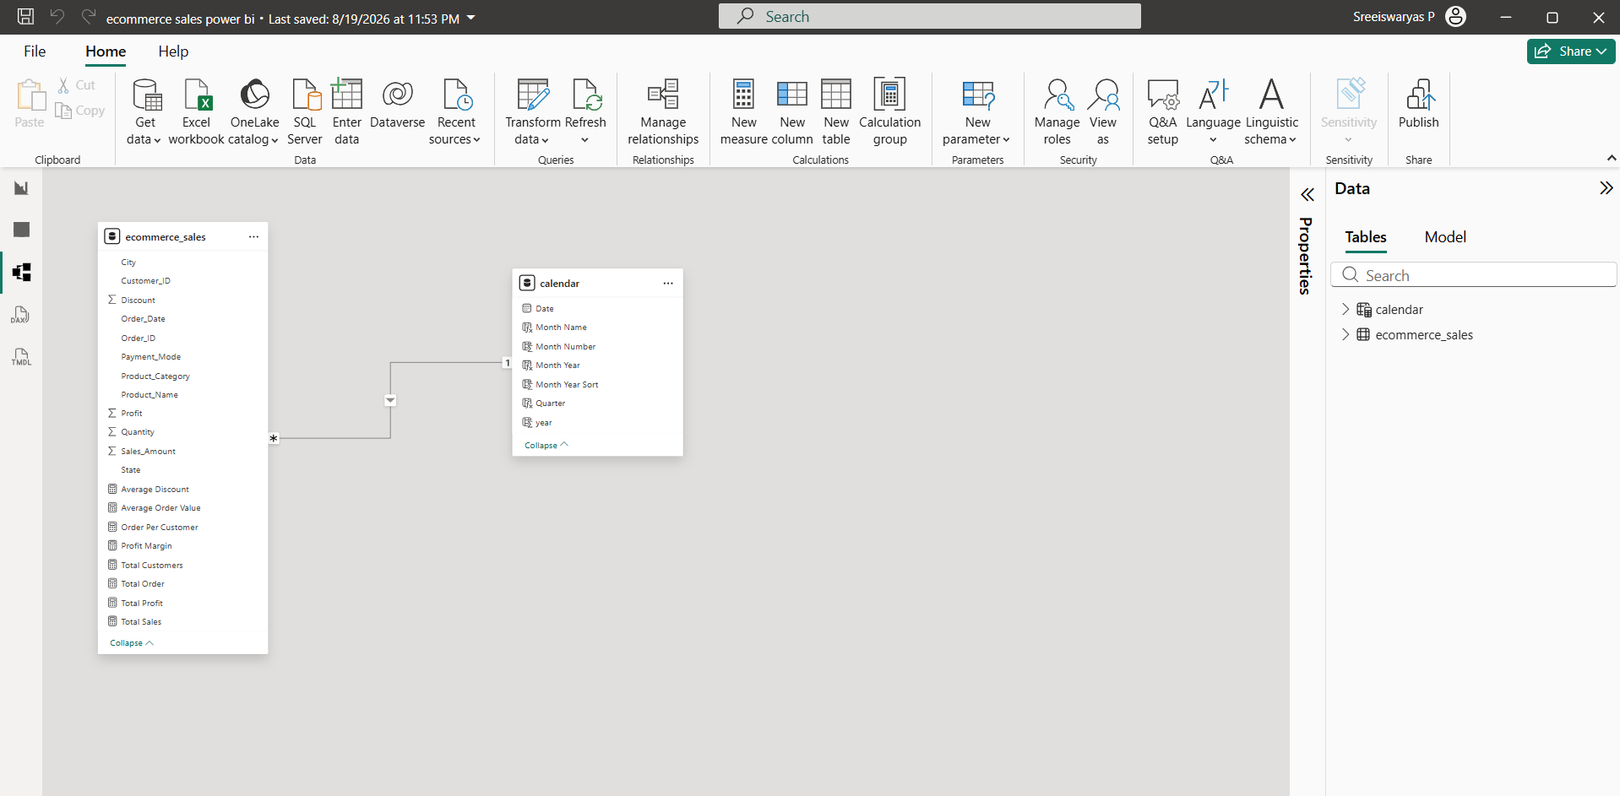

DAX Measures:
- Total Sales
Total Sales = sum(ecommerce_sales[Sales_Amount])
- Total Profit
Total Profit = sum(ecommerce_sales[Profit])
- Total Orders
Total Orders = distinctcount(ecommerce_sales[Order_ID])
- Total Customers
Total Customers = distinctcount(ecommerce_sales[Customer_ID])
- Orders per Customer
Orders per Customer = divide([Total Orders], [Total Customer],0)
- Profit Margin
Profit Margin = divide([Total Profit],[Total Sales],0)
- Average Order Value
Average Order Value = divide([Total Sales],[Total Order],0)
- Average Discount
Average Discount = average(ecommerce_sales[Discount])

Power BI Dashboard:
Executive Dashboard:
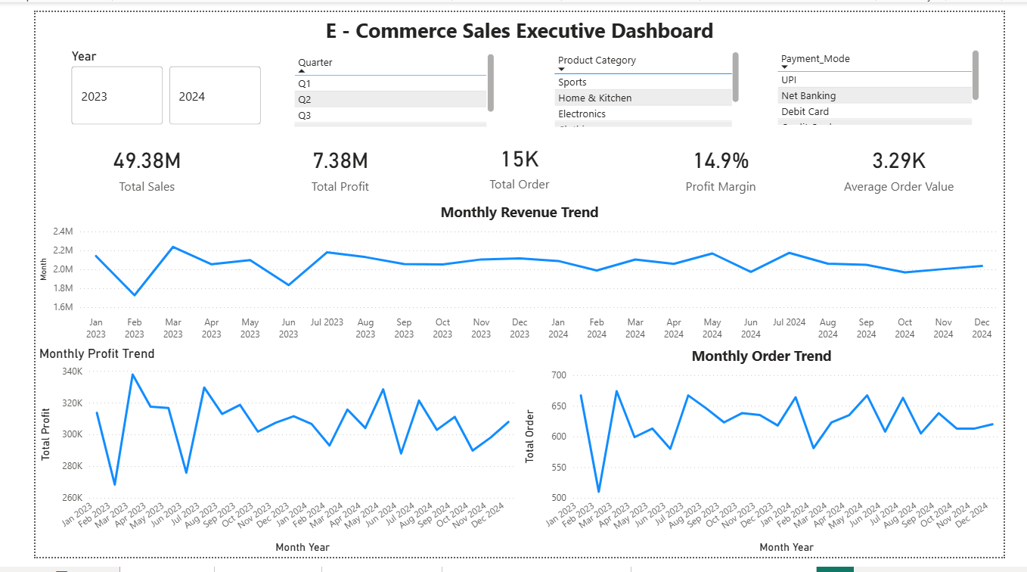

Sales Analysis:
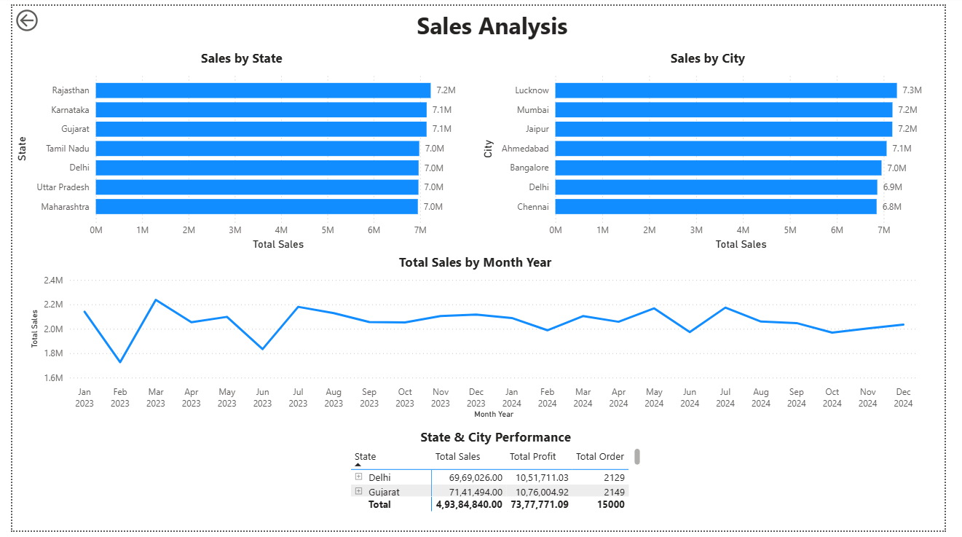

Product Analysis:
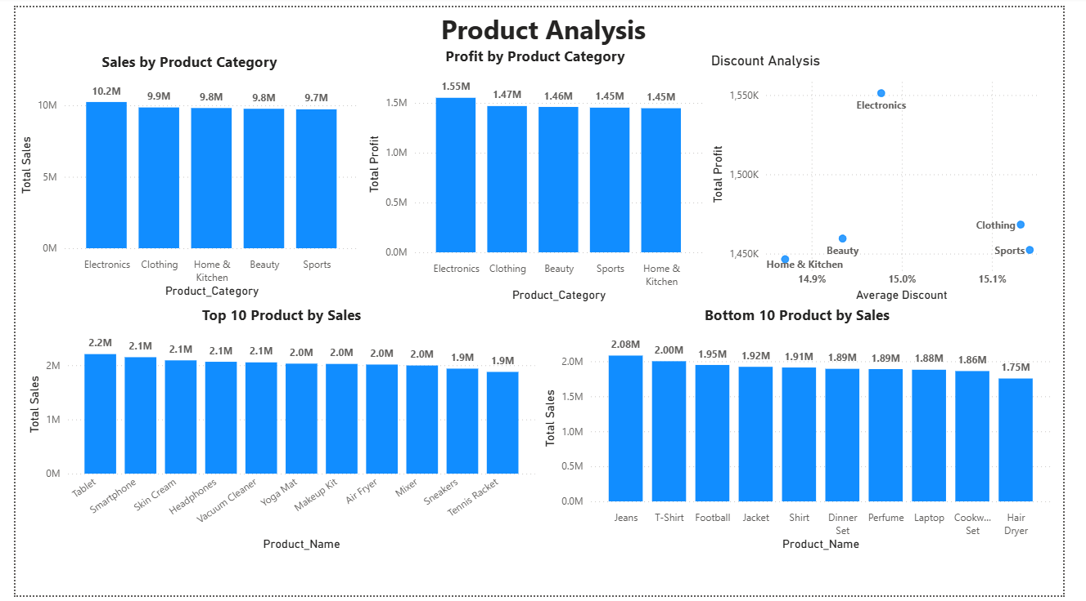

Customer & Payment Analysis:
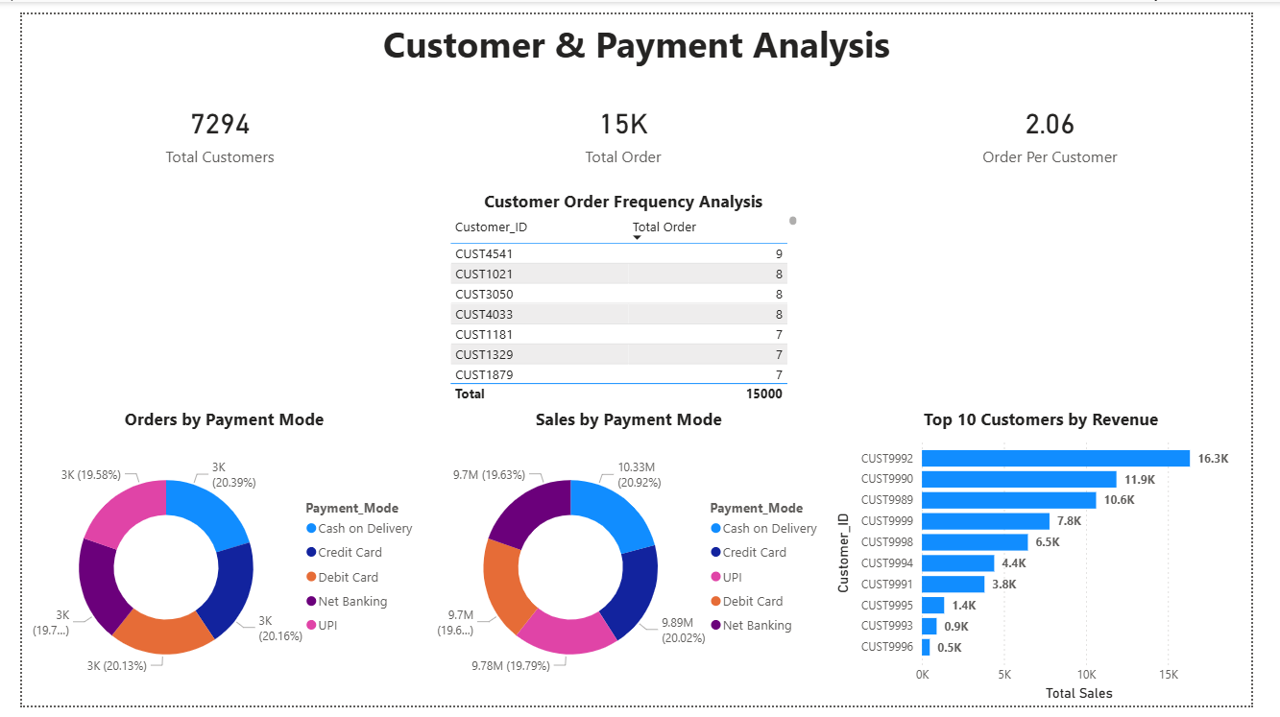

Insights & Recommendations:
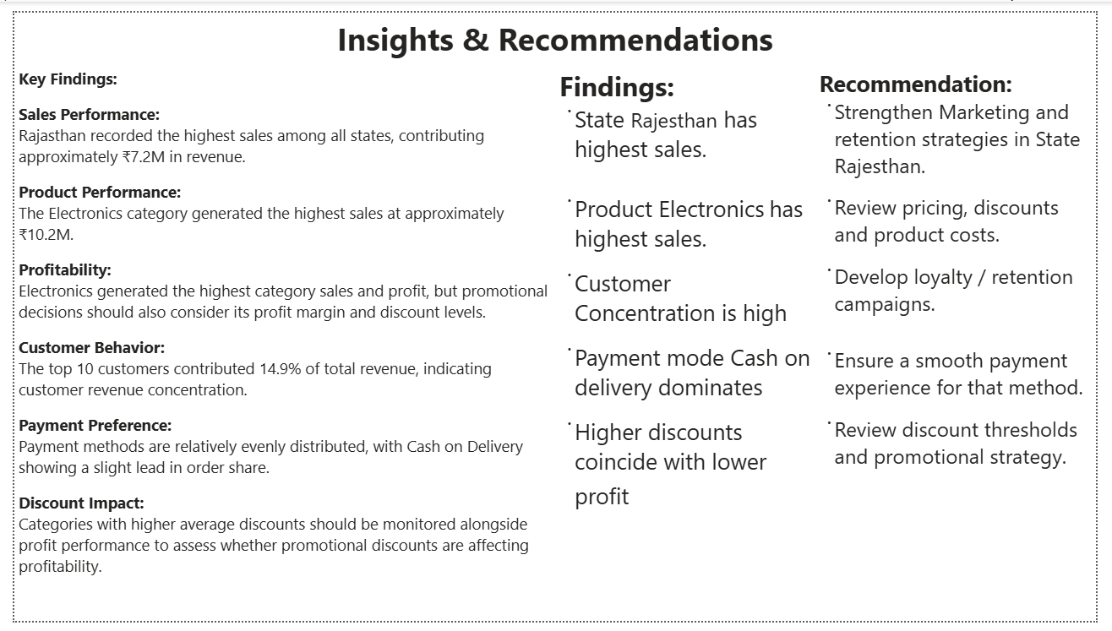

Business Insights:
Area | Finding | Business Meaning
Sales | Rajasthan has highest sales | Strong regional performance
Product | Electronics has highest sales | Strong demand
Customer | Small group contributes significant revenue | Customer concentration
Payment | Cash on Delivery is widely used | Important payment preference
Discount | Higher discounts coincide with lower profit | Discount strategy needs review

Business Recommendations:
- Regional Strategy:
Strengthen marketing and customer retention strategies in Rajasthan because it is the highest – performing state.

- Product Strategy:
Continue monitoring Electronics performance while evaluating profitability before increasing promotional spending.

- Customer Retention:
Develop loyalty and retention campaigns for high – value customers.

- Payment:
Maintain a smooth Cash – on – Delivery experience because it represents a significant payment preference.

- Discount Strategy:
Review discount thresholds to ensure that promotional activity does not unnecessarily reduce profitability.

Executive Summary:
This project analyses e – commerce transactional data to understand sales, profitability, customer behavior, product performance, payment preferences and regional performance. MySQL was used for data preparation and business analysis, while Power BI was used to create an interactive dashboard.
The analysis identified the major sales – performing regions, products, customer patterns and payment preferences. The dashboard provides stakeholders with an interactive view of business performance through KPIs and visual analysis.
Based on the findings, recommendations were developed around regional marketing, product profitability, customer retention, payment experience and discount management.

Limitations:
- Analysis is based only on the available dataset.
- Historical data may not represent future performance.
- No predictive modelling was performed.
- Customer demographic information may be limited.
- External factors such as competitors, seasonality and market conditions are not included.
- Discount impact is based on observed transactional data and does not establish causation.

Future Scope:
- Develop sales forecasting
- Build customer segmentation
- Perform RFM analysis
- Develop customer churn analysis
- Analyze seasonal trends
- Add profitability forecasting
- Integrate real – time sales data
- Build automated Power BI refresh
- Include marketing campaign data
- Apply predictive analytics

Conclusion:
The E – Commerce Sales Analysis project demonstrates how raw transactional data can be transformed into actionable business insights using MySQL and Power BI. Data cleaning and exploratory analysis helped establish reliable data, while SQL – based business analysis identified important trends in sales, products, customers, payment methods and regional performance. The Power BI dashboard provides an interactive platform for monitoring KPIs exploring business performance. The findings and recommendations can support better decisions related to sales strategy, customer retention, product management and profitability.

